Git Cleanup and Push Exercise Report
Repository: Cognizant_assessment
Week: WEEK - 7
Exercise: 5. Git-HOL

Step 1: Verify Repository Status
Verified current branch and working tree using git status.
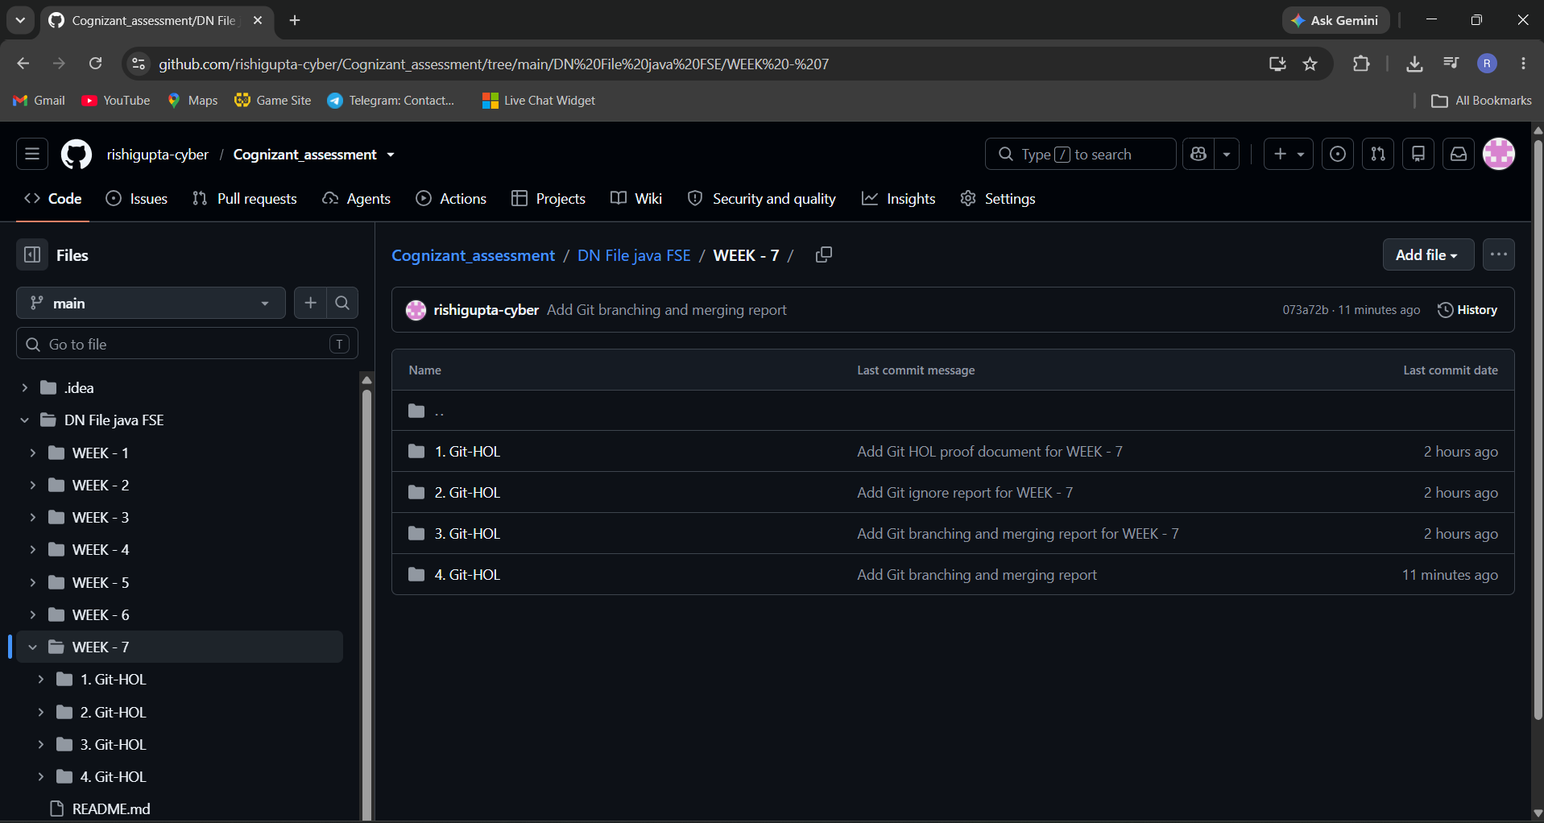

Step 2: Verify Branch
Verified active branch using git branch.
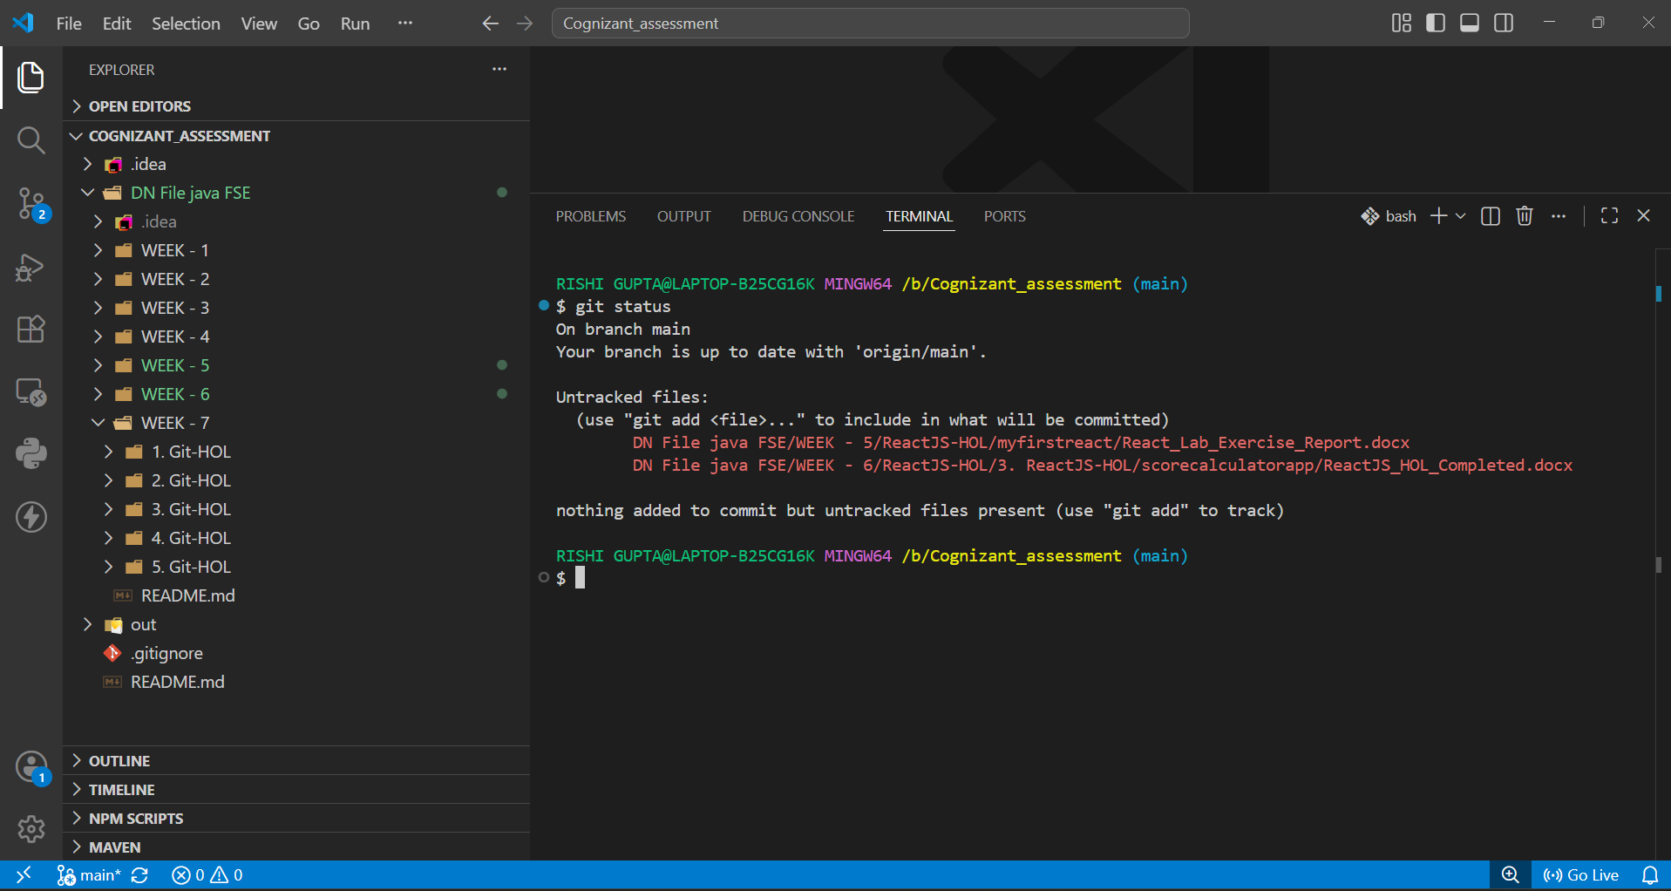

Step 3: Synchronize Repository
Executed git pull origin main and confirmed repository was already up to date.
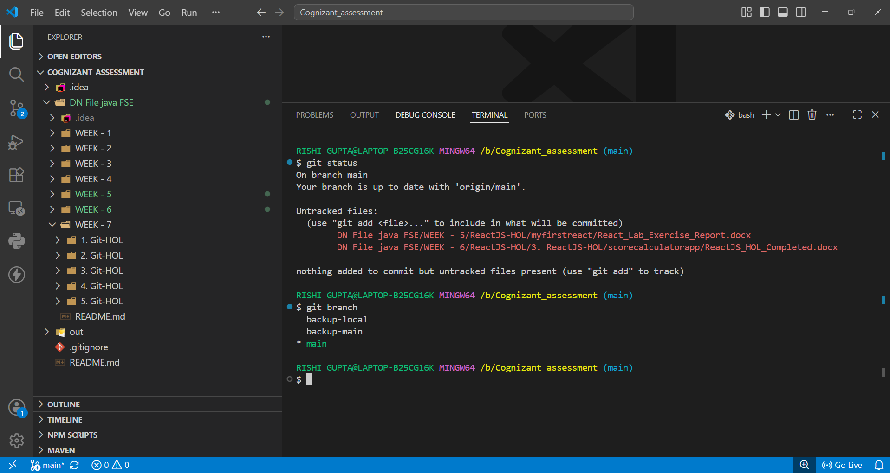

Step 4: Push Changes
Executed git push origin main and confirmed 'Everything up-to-date'.
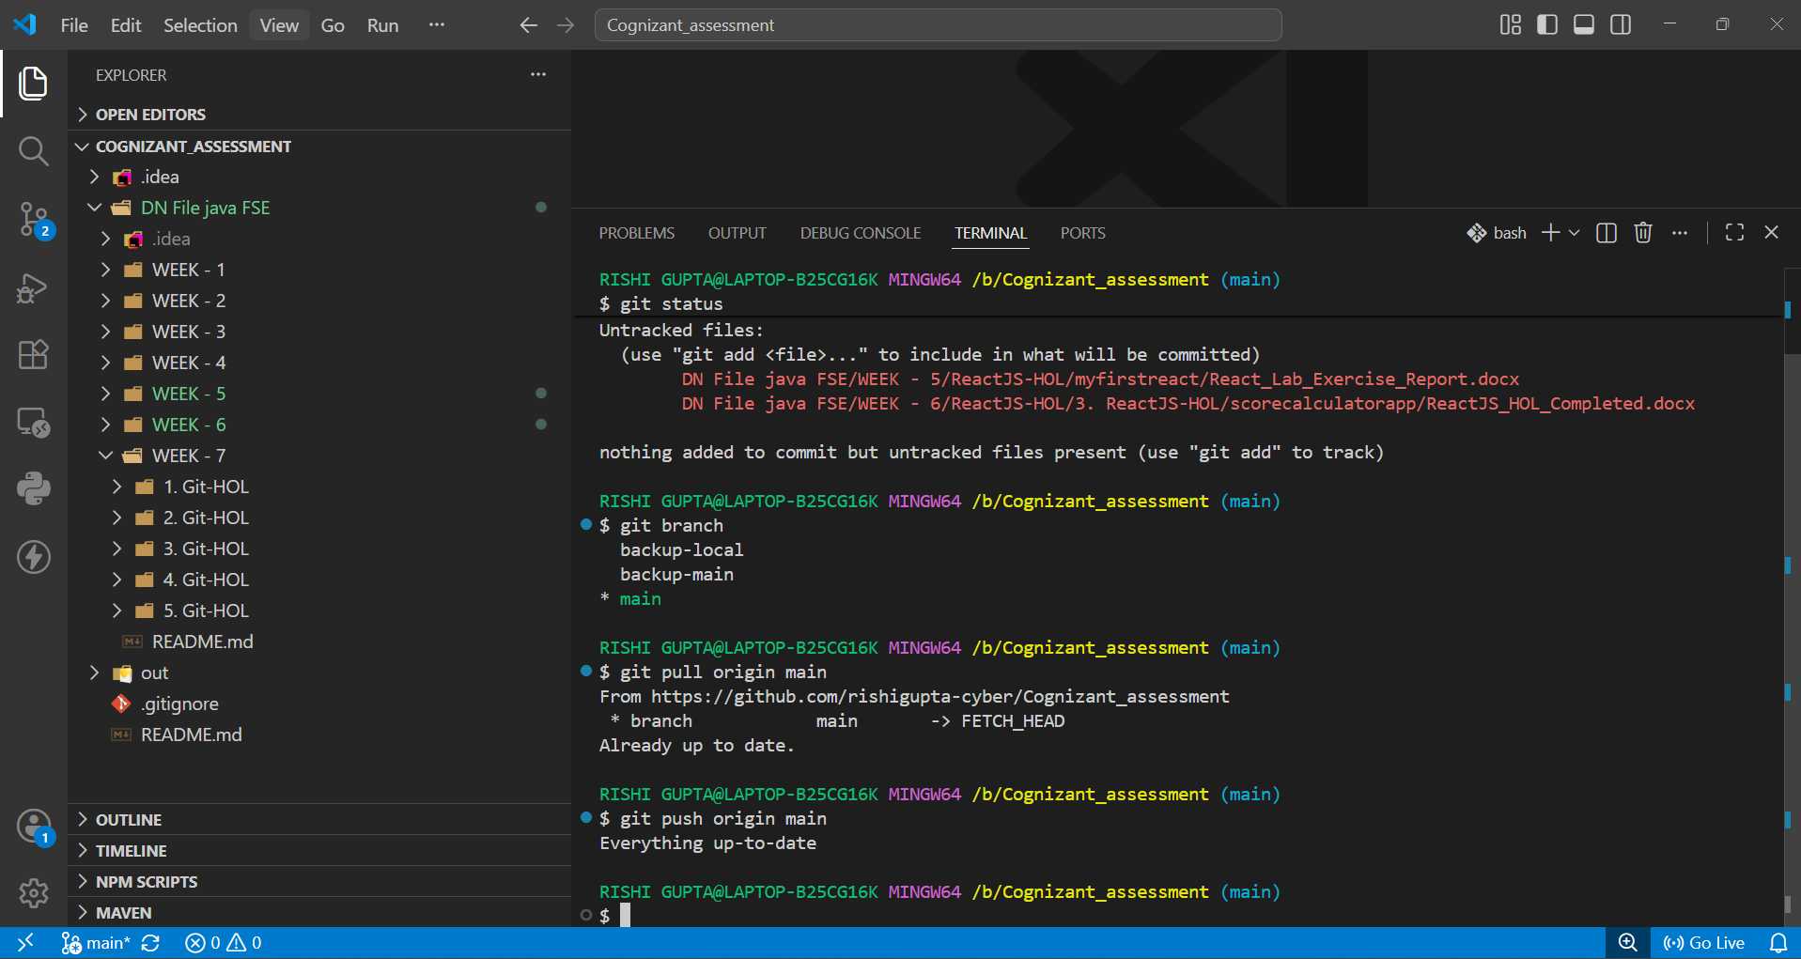

Conclusion
The repository was verified, synchronized with the remote repository, and confirmed to be fully up to date. No additional commits were pending for push.

